|  |  |  |
| --- | --- | --- |
|  | SHRI VILEPARLE KELAVANI MANDAL’S  **SHRI BHAGUBHAI MAFATLAL POLYTECHNIC** |  |

R E P O R T

on

**“BLIND GUIDE”**

**Diploma**

in

**Computer Engineering**

Submitted by:

**1.Sufiyan Dalvi (1781005)**

**2.Chirag Dodia (1781011)**

**3.Aarshi Jethwa (1781022)**

Under the guidance of:

**Mr. Pratik Shah**

**Department of Computer Engineering**

**(2019-2020)**

**TABLE OF CONTENT:**

|  |  |  |
| --- | --- | --- |
| **Sr.no** | **Contents** | **Page Number** |
|  | **Abstract** | **3** |
|  | **Problem statement** | **3** |
|  | **System requirement specification** | **4** |
|  | **Proposed solution** | **4** |
|  | **Estimation and planning** | **5** |
|  | **Future scope** | **5** |
|  | **Conclusion** | **5** |
|  | **Bibliography and references** | **6** |

ABSTRACT**:**

Blind mobility is one of the major challenges encountered by visually impaired persons in their daily lives. Their life and activities are greatly restricted by loss of eyesight. They normally travel using blind navigation system or by their accumulated memories in their long term exploration. The main objective of the present work is to develop a low cost, reliable, portable, user friendly, low power and robust solution for smooth navigation. There are multiple smart accessories such as smart glasses, smartwatches, etc. available in the market. But all of them are built for us. There is a significant lack of technology to aid the physically challenged. We wanted to build something that is useful for visually challenged people. So we designed low-cost smart glass that can be used to help the visually impaired.

This report ( Blind guide), as meant are the glasses are for visually impaired people. It has an in-built sensor in it which spreads ultrasonic waves in the direction the person is going by scanning at most 5-6 meters of 30o range. As soon as the obstacle is detected, the sensor detects it and sends it to the device which generates an automated voice in the earphone connected to the person's ear.

This project uses a few ultrasonic distance sensors, an Arduino Pro Mini, an MP3 player module, and some vibration motors.

The circuit board used in this project is designed in the form of a spectacle, which can be worn by a visually impaired person. An Arduino mounted on the spectacle will detect the obstacle with the help of the sensors and notify the user through headphones and vibration motors.

CHAPTER 1: INTRODUCTION (DOMAIN)

The Internet of Things, or IoT, refers to the billions of physical devices around the world that are now connected to the internet, all collecting and sharing data. Thanks to the arrival of super-cheap computer chips and the ubiquity of wireless networks, it's possible to turn anything, from something as small as [a pill](https://www.zdnet.com/article/how-sensors-enabled-eli-lilly-to-improve-the-patient-experience/)to something as big as [an aeroplane](https://www.zdnet.com/article/ten-examples-of-iot-and-big-data-working-well-together/), into a part of the IoT. Connecting up all these different objects and adding sensors to them adds a level of digital intelligence to devices that would be otherwise dumb, enabling them to communicate real-time data without involving a human being. The Internet of Things is making the fabric of the world around us smarter and more responsive, merging the digital and physical universes.

The Internet of things (IoT) is a system of interrelated computing devices, mechanical and digital machines provided with unique [identifiers](https://en.wikipedia.org/wiki/Identifiers) (UIDs) and the ability to transfer data over a network without requiring human-to-human or human-to-computer interaction.

The definition of the Internet of things has evolved due to the convergence of multiple technologies, real-time [analytics](https://en.wikipedia.org/wiki/Analytics), [machine learning](https://en.wikipedia.org/wiki/Machine_learning), [commodity](https://en.wikipedia.org/wiki/Commodity) [sensors](https://en.wikipedia.org/wiki/Sensors), and [embedded systems](https://en.wikipedia.org/wiki/Embedded_system).[[1]](https://en.wikipedia.org/wiki/Internet_of_things#cite_note-Linux_Things-1) Traditional fields of [embedd systems](https://en.wikipedia.org/wiki/Embedded_system" \o "Embedded system), [wireless sensor networks](https://en.wikipedia.org/wiki/Wireless_sensor_network), [control systems](https://en.wikipedia.org/wiki/Control_system), [automation](https://en.wikipedia.org/wiki/Automation) (including [home](https://en.wikipedia.org/wiki/Home_automation) and [building automation](https://en.wikipedia.org/wiki/Building_automation)), and others all contribute to enabling the Internet of things. In the consumer market, IoT technology is most synonymous with products pertaining to the concept of the "[smart home](https://en.wikipedia.org/wiki/Smart_home_technology)", covering devices and [appliances](https://en.wikipedia.org/wiki/Home_appliance) (such as lighting fixtures, [thermostats](https://en.wikipedia.org/wiki/Thermostats), home [security systems](https://en.wikipedia.org/wiki/Security_systems) and cameras, and other home appliances) that support one or more common ecosystems, and can be controlled via devices associated with that ecosystem, such as [smartphones](https://en.wikipedia.org/wiki/Smartphone) and [smart speakers](https://en.wikipedia.org/wiki/Smart_speaker).

Applications

**Consumer applications**

**Smart home**

**Elder care**

**Commercial application**

**Medical and healthcare**

**Transportation**

**Building and home automation**

**Industrial applications**

**Manufacturing**

**Agriculture**

**Infrastructure applications**

**Metropolitan scale deployments**

**Energy management**

**Environmental monitoring**

**Chapter 2:**

**PROBLEM STATEMENT:**

On an approximation 285 million people are visually impaired across the globe, among which 39 million are blind and 246 have low vision according to WHO statistics of 2011 [1]. About 90% of the world's visually impaired live in low-income settings whereas 82% of people living with blindness are aged 50 and above. India is now home to the world's largest number of 102 blinds. Out of the 37 million blind people worldwide, over 15 million are from India. The worst thing is that 75% of these are cases of avoidable blindness. India has an acute shortage of optometrists and donated eyes for the treatment of corneal blindness. While India needs 40,000 optometrists, it has only 8,000. Blind people are usually dependent on assistance from others. The assistance can be from human beings, dogs or some special electronic devices. There are already many existing devices which help a blind person in walking. The most common is the simple walking stick or cane. The blind man uses it to detect the obstacles by sweeping the cane back and forth but unfortunately sometimes the blind man gets aware about the obstacle too late. With the recent advances in technology normal walking cane has been modified to a blind stick with an ultrasonic sensor attached to it. It has several limitations.

**PROPOSED SYSTEM:**

Therefore, the system that has been portrayed in this report is cost effective, reliable, robust and portable device which would help a blind person to walk on the streets almost like any other pedestrian. Glasses can be designed for blind people. The concept of obstacle detection by SONAR sensor has been used here. As soon as the obstacle is detected by the sensor, its distance it sent to the customized PCB. We convert the distance into centimeters from milliseconds and the check whether the distance of obstacle is less than 3m, if yes then we send the output through a buzzer. The beeping of the buzzer is directly proportional to the distance of the obstacle from human. the beeping sound frequency keeps increasing as sensors get closer to the obstacle

ESTIMATION AND PLANNING:

In the project planning, basically it will contain a rough layout of the plans needed to be carried by on a daily basis and this count will be maintained till the completion of the project.

|  |  |  |  |  |  |  |  |  |  |  |  |  |  |  |  |  |  |  |  |  |
| --- | --- | --- | --- | --- | --- | --- | --- | --- | --- | --- | --- | --- | --- | --- | --- | --- | --- | --- | --- | --- |
|  | **December** | | | | **January** | | | | **February** | | | | **March** | | | | **April** | | | |
| **Activities/Weeks** | **1** | **2** | **3** | **4** | **5** | **6** | **7** | **8** | **9** | **10** | **11** | **12** | **13** | **14** | **15** | **16** | **17** | **18** | **19** | **20** |
| Decide Goal of the project |  |  |  |  |  |  |  |  |  |  |  |  |  |  |  |  |  |  |  |  |
| Name and approach |  |  |  |  |  |  |  |  |  |  |  |  |  |  |  |  |  |  |  |  |
| Hardware and software requirements |  |  |  |  |  |  |  |  |  |  |  |  |  |  |  |  |  |  |  |  |
| Work on project |  |  |  |  |  |  |  |  |  |  |  |  |  |  |  |  |  |  |  |  |
| Test the project |  |  |  |  |  |  |  |  |  |  |  |  |  |  |  |  |  |  |  |  |
| Make the required changes |  |  |  |  |  |  |  |  |  |  |  |  |  |  |  |  |  |  |  |  |
| Finalize the project |  |  |  |  |  |  |  |  |  |  |  |  |  |  |  |  |  |  |  |  |

The diagram is a basic prototype of how the planning was carried out on the daily basis and all the task which are in the process of completing and the task which has been completed, all will be accounted into the chart of objectives. Like this all the task will be listed into the chart and till the project gets complete it will be updated periodically.

Description

There are multiple smart accessories such as smart glasses, smart watches, etc. available in the market. But all of them are built for us. There is a significant lack of technology to aid the physically challenged.We wanted to build something that is useful for the visually challenged people. So we designed a low-cost smart glass that can be used to help the visually impaired.This project uses a few ultrasonic distance sensors, an Arduino Pro Mini, an *MP3* player module, and some vibration motors. This project in the form of a spectacle, which can be worn by a visually impaired person. An Arduino mounted on the spectacle will detect the obstacle with the help of the sensors and notify the user distance and direction of the obstacle through headphones

The main objective of our present work is to provide a reliable, cost effective, low power solution for a blind people which would help them to move almost like any other normal pedestrian. The cost of this system makes it affordable for the majority of the society which in turn an effective device for them to spend on, just for once and assures wonderful travel guidance for them.

I/O statement

INPUT

The HC-SR04 ultrasonic sensing element uses echo sounder to work out the gap to an object like

dolphins do. It offers wonderful non-contact detection with high accuracy associated stable readings in

an easy-to-use package from two cm to four hundred cm. Its operation isn’t restricted by daylight or

black material. It comes with a transmitter and recipient

As shown above the **HC-SR04 Ultrasonic (US) sensor** is a 4 pin module, whose pin names are Vcc, Trigger, Echo and Ground respectively. This sensor is a very popular sensor used in many applications where measuring distance or sensing objects are required. The module has two eyes like projects in the front which forms the Ultrasonic transmitter and Receiver. The sensor works with the simple high school formula that

**Distance = Speed × Time**

The Ultrasonic transmitter transmits an ultrasonic wave, this wave travels in air and when it gets objected by any material it gets reflected back toward the sensor this reflected wave is observed by the Ultrasonic receiver module as shown in the picture below

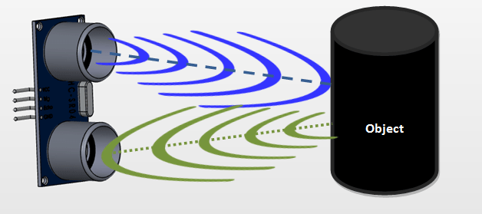

Now, to calculate the distance using the above formulae, we should know the Speed and time. Since we are using the Ultrasonic wave we know the universal speed of US wave at room conditions which is 330m/s. The circuitry inbuilt on the module will calculate the time taken for the US wave to come back and turns on the echo pin high for that same particular amount of time, this way we can also know the time taken. Now simply calculate the distance using a microcontroller or microprocessor.

OUTPUT

Once the obstacle is detected and the input is received the user will get the output in the form of sound using a earphone mentioning the distance at which the obstacle is detected and through a vibrating signal which will be provided using a coin vibrating motor

Chapter 3:

**Literature review**

**A. Obstacle Avoidance**

There exist a vast literature on obstacle detection and avoidance. According to the sensor type, the obstacle avoidance method can be categorized as: ultrasonic sensor based method, laser scanner based method , and camera based method. Ultrasonic sensor based method can measure the distance of obstacle and compare it with the given distance threshold for deciding whether to go ahead, but it cannot determine the exact direction of going forward, and may suffer from interference problems with the sensors themselves if ultrasonic radar (ultrasonic sensor array) is used, or other signals in indoor environment. Although laser scanner based method is widely used in mobile robot navigation for their high precision and resolution, the laser scanner is expensive, heavy, and with high power consumption, so it is not suitable for wearable navigation system. As for camera based method, there are many methods based on different cameras, such as mono-camera, stereo-camera, and RGB-D camera. Based on the mono-camera, some methods process RGB image to detect obstacles by e.g., floor segmentation, deformable grid based obstacle detection, etc.

**B. Guiding Information Feedback**

There are three main techniques for providing guiding information to visually impaired people, i.e., haptic, audio and visual. Haptic feedback based systems often use vibrators on a belt, helmet or in a backpack. Although they have far less interference with sensing the environment, they are hard to represent complicated information and require more training and concentration. Audio feedback based systems utilize acoustic patterns, semantic speech, different intensities sound or spatially localized auditory cues. The method in, directly maps the processed RGB image to acoustic patterns for helping the blind to perceive the surroundings. The method maps the depth image to semantic speech for telling the blind some information about the obstacles. The method maps the depth image to different intensities sound for representing obstacles in different distance. The method maps the depth image to spatially localized auditory cues for expressing the 3D information of the surroundings. However, the user will misunderstand these auditory cues under noisy or complicated environment. Visual feedback based systems can be used for the partially sighted individuals due to its ability of providing more detailed information than haptic or audio feedback based systems. The method in maps the distance of the obstacle to brightness on LED (Light Emitting Diode) display as a visual enhancement method to help the users more easily to notice the obstacle. But, the LED display only shows the large obstacle due to its low resolution.

**CHAPTER4: DESIGN AND IMPLEMENTATION**

**Architecture**

**Block Diagram:**

**Vibrator**

**Ultrasonic Sensor**

**MP3 Player**

**Speaker**

#### Arduino

#### Micro-Controller

**Battery**

**H/S requirement:**

**Hardware**

* 1 * HC SR04 Ultrasonic distance sensor.
* 1 * DF Player mini.
* 1 * Vibration motors.
* 3.5mm audio jack.
* 1* slide switch.
* 1 * SD card
* 1* arudino nano
* Bread boards
* Jumper wires
* 9V batteries
* 2 layer PCB

**Software**

* Ardino

**HC SR04 Ultrasonic distance sensor**

## Ultrasonic Sensor Arduino Interfacing - The Engineering Projects

## HC-SR04 Hardware

At its core, the HC-SR04 Ultrasonic distance sensor consists of two ultrasonic transducers. The one acts as a transmitter which converts electrical signal into 40 KHz ultrasonic sound pulses. The receiver listens for the transmitted pulses. If it receives them it produces an output pulse whose width that can be used to determine the distance the pulse travelled.

The sensor is small, easy to use in any robotics project and offers excellent non-contact range detection between 2 cm to 400 cm (that’s about an inch to 13 feet) with an accuracy of 3mm. Since it operates on 5 volts, it can be hooked directly to an Arduino or any other 5V logic microcontrollers.

Pins:

* VCC: +5VD
* Trig : Trigger (INPUT)
* Echo: Echo (OUTPUT)

GND: GND

**DFPlayer Mini MP3**

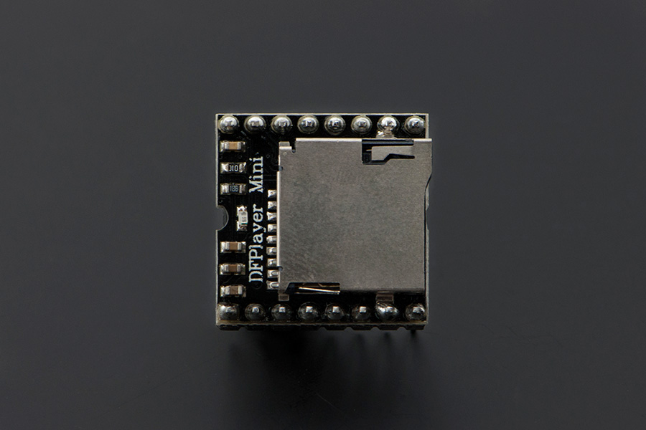

The [DFPlayer Mini MP3 Player For Arduino](https://www.dfrobot.com/product-1121.html) is a small and low price MP3 module with an simplified output directly to the speaker. The module can be used as a stand alone module with attached battery, speaker and push buttons or used in combination with an [**Arduino UNO**](https://www.dfrobot.com/product-610.html) or any other with RX/TX capabilities.

## Specification

* supported sampling rates (kHz): 8/11.025/12/16/22.05/24/32/44.1/48
* 24 -bit DAC output, support for dynamic range 90dB , SNR support 85dB
* fully supports FAT16 , FAT32 file system, maximum support 32G of the TF card, support 32G of U disk, 64M bytes NORFLASH
* a variety of control modes, I/O control mode, serial mode, AD button control mode
* advertising sound waiting function, the music can be suspended. when advertising is over in the music continue to play
* audio data sorted by folder, supports up to 100 folders, every folder can hold up to 255 songs
* 30 level adjustable volume, 6 -level EQ adjustable

## Application

* Car navigation voice broadcast;
* Road transport inspectors, toll stations voice prompts;
* Railway station, bus safety inspection voice prompts;
* Electricity, communications, financial business hall voice prompts;
* Vehicle into and out of the channel verify that the voice prompts;
* The public security border control channel voice prompts;
* Multi-channel voice alarm or equipment operating guide voice;
* The electric tourist car safe driving voice notices;
* Electromechanical equipment failure alarm;
* Fire alarm voice prompts;
* The automatic broadcast equipment, regular broadcast.

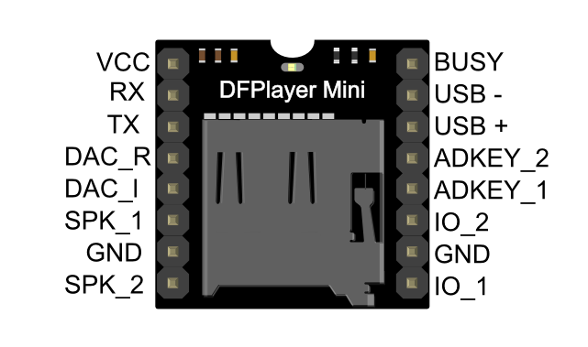

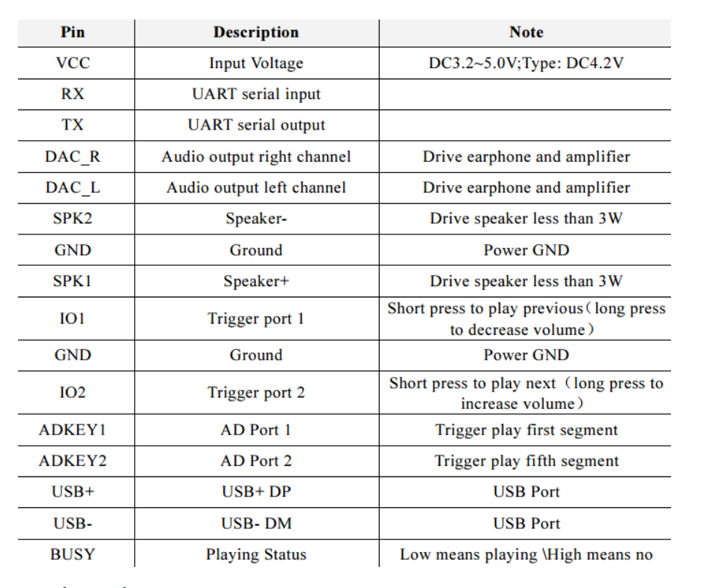

**Coin Vibration Motors**

Precision Microdrives currently produces coin vibration motors, also known as shaftless or pancake vibrator motors, generally in Ø8mm - Ø12mm diameters for our Pico Vibe range. Pancake motors are compact and convenient to use. They integrate into many designs because they have no external moving parts, and can be affixed in place with a strong permanent self-adhesive mounting system.

Enclosures can easily be moulded to accept the coin form of our shaftless vibration motors. Within the coin motor range, we offer both leaded and spring & pad mountable versions. Like all of our vibration motors, we are happy to quote for variations to the base design such as a modification to the lead length and also connectors.

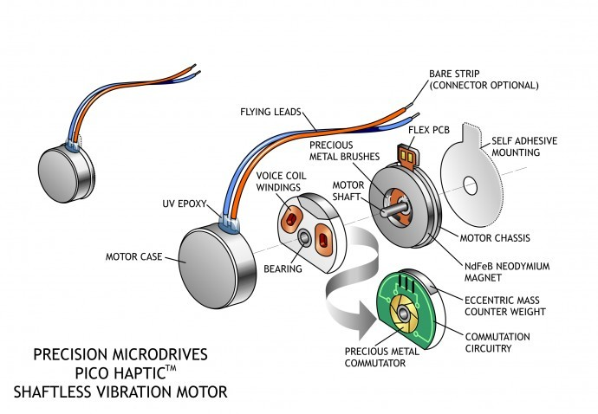

Applications

Due to their small size and enclosed vibration mechanism, coin vibrating motors are a popular choice for many different applications. They are great for haptics, particularly in handheld instruments where space can be at a premium:

* Mobile phones
* RFID scanners
* Industrial tools or equipment user interfaces
* Portable instruments
* Medical applications

**General Layout And Operation**

Our coin or pancake vibrating motors are all Eccentric Rotating Mass (ERM) motors. Therefore they can be driven in the same manner as their pager motor counterparts. They have the same motor drive principles, including H-bridge circuitry for active braking.

Brushed coin vibration motors are constructed from a flat PCB on which the 3-pole commutation circuit is laid out around an internal shaft in the centre. The vibration motor rotor consists of two 'voice coils' and a small mass that is integrated into a flat plastic disc with a bearing in the middle, which sits on a shaft. Two brushes on the underside of the plastic disc make contact to the PCB commutation pads and provide power to the voice coils which generate a magnetic field. This field interacts with the flux generated by a disc magnet that is attached to the motor chassis.

The commutation circuit alternates the direction of the field through the voice coils, and this interacts with the N-S pole pairs that are built into the neodymium magnet. The disc rotates and, due to the built-in off-centred eccentric mass, the motor vibrates.

**Audio jack**

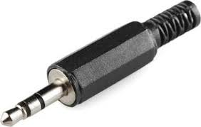

A phone connector, also known as phone jack, audio jack, headphone jack or jack plug, is a family of electrical connectors typically used for [analog audio signals](https://en.wikipedia.org/wiki/Analog_signal). The standard is that a plug (described as the male connector) will connect with a jack (described as female).

The phone connector is cylindrical in shape, with a grooved tip to retain it. In its original audio configuration, it typically has two, three, four and, occasionally, five contacts. Three-contact versions are known as TRS connectors, where T stands for ["tip"](https://en.wikipedia.org/wiki/Tip_and_ring), R stands for ["ring"](https://en.wikipedia.org/wiki/Tip_and_ring) and S stands for "sleeve". Ring contacts are typically the same diameter as the sleeve, the long shank. Similarly, two-, four- and five- contact versions are called TS, TRRS and TRRRS connectors respectively. The outside diameter of the "sleeve" conductor is 6.35 millimetres (1⁄4 inch). The "mini" connector has a diameter of 3.5 mm (0.14 in) and the "sub-mini" connector has a diameter of 2.5 mm (0.098 in).

Specific models, and connectors used in specific applications, may be termed e.g. stereo plug, headphone jack, microphone jack, aux input, etc. The 3.5 mm versions are commonly called mini-phone, mini-stereo, mini jack, etc

Connectors that are tarnished, or that were not manufactured within tight tolerances, are prone to cause poor connections.[[74]](https://en.wikipedia.org/wiki/Phone_connector_(audio)#cite_note-soundonsound-2005-06-76) Depending upon the surface material of the connectors, tarnished ones can be cleaned with a burnishing agent (for solid brass contacts typical) or contact cleaner (for plated contacts).

**SD card**

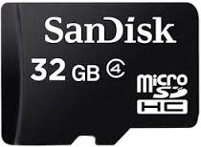

**Secure Digital**, officially abbreviated as **SD**, is a [proprietary](https://en.wikipedia.org/wiki/Proprietary_format) [non-volatile](https://en.wikipedia.org/wiki/Non-volatile_memory) [memory card](https://en.wikipedia.org/wiki/Memory_card) format developed by the [SD Card Association](https://en.wikipedia.org/wiki/SD_Card_Association) (SDA) for use in portable devices.

Secure Digital includes five card families available in three different sizes. The five families are the original Standard-Capacity (SDSC), the High-Capacity (SDHC), the Extended -Capacity ([SDXC](https://en.wikipedia.org/wiki/SD_card#SDXC)), the Ultra-Capacity ([SDUC](https://en.wikipedia.org/wiki/SD_card#SDUC)) and the [SDIO](https://en.wikipedia.org/wiki/SD_card#SDIO_cards), which combines [input/output](https://en.wikipedia.org/wiki/Input/output) functions with data storage. The [three form factors](https://en.wikipedia.org/wiki/SD_card#Physical_size) are the original size, the mini size, and the micro size. Electrically passive adapters allow a smaller card to fit and function in a device built for a larger card. The SD card's small footprint is an ideal storage medium for smaller, thinner and more portable electronic devices.

**Arduino Nano**

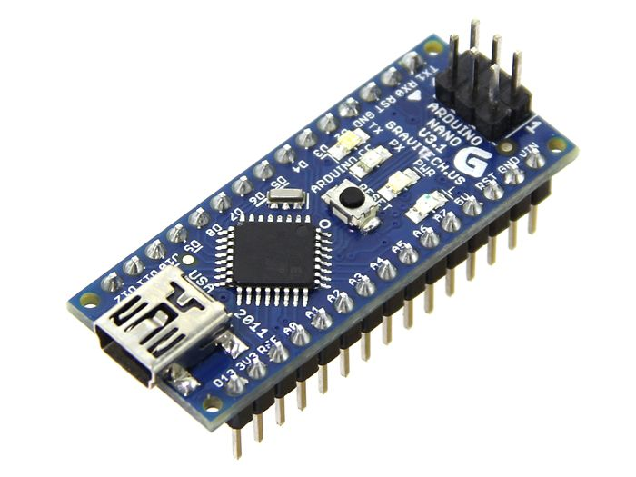

Arduino Nano is a microcontroller board based on the ATmega328P. It has 14 digital input/output pins (of which 6 can be used as PWM outputs), 6 analog inputs, a 16 MHz quartz crystal, a USB connection, a power jack, an ICSP header and a reset button. It contains everything needed to support the microcontroller; simply connect it to a computer with a USB cable or power it with a AC-to-DC adapter or battery to get started.

"Nano" means one in Italian and was chosen to mark the release of Arduino Software (IDE) 1.0. The Nano board and version 1.0 of Arduino Software (IDE) were the reference versions of Arduino, now evolved to newer releases. The Nano board is the first in a series of USB Arduino boards, and the reference model for the Arduino platform; for an extensive list of current, past or outdated boards see the Arduino index of boards.

**Components Overview**

The PCB design of the Arduino NANO uses SMD (Surface Mount Device) components. I entered the SMD world years ago when I dug into Arduino PCB design while I was a part of a team redesigning a DIY clone for Arduino NANO.

Integrated circuits use standardized packages, and there are families for packages.

The dimensions of many SMD resistors, capacitors, and LEDs are indicated by package codes such as the following

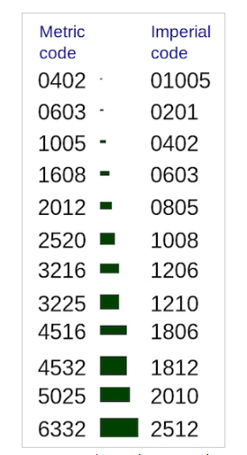

Most packages are generic and can be used for different parts with different functionality. The SOT-223 package, for example, can contain a transistor or a regulator.

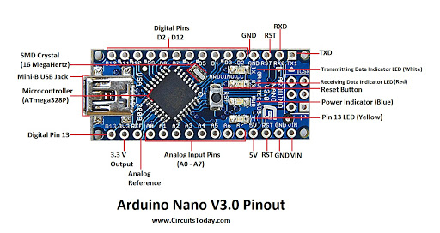

In the table below, you can see a list of some components in the Arduino NANO with their respective package:

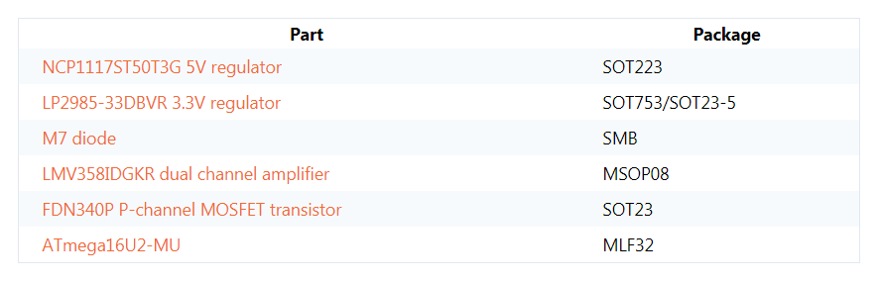

**Arduino NANO System Overview**

Before we can understand the NANO's hardware, we must have a general overview of the system first.

After your code is compiled using Arduino IDE, it should be uploaded to the main microcontroller of the Arduino NANO using a USB connection. Because the main microcontroller doesn’t have a USB transceiver, you need a bridge to convert signals between the serial interface (UART interface) of the microcontroller and the host USB signals.

The bridge in the latest revision is the ATmega16U2, which has a USB transceiver and also a serial interface (UART interface).

To power your Arduino board, you can use the USB as a power source. Another option is to use a DC jack. You may ask, “if I connect both a DC adapter and the USB, which will be the power source?” The answer will be discussed in the “Power Part” section from this article.

To reset your board, you should use a push button in the board. Another source of reset should be every time you open the serial monitor from Arduino IDE.

**The Microcontroller**

The ATmega328 microcontroller is the MCU used in Arduino NANO R3 as a main controller. ATmega328 is an MCU from the AVR family; it is an 8-bit device, which means that its data-bus architecture and internal registers are designed to handle 8 parallel data signals.

**ATmega328 has three types of memory:**

**Flash memory:** 32KB nonvolatile memory. This is used for storing application, which explains why you don't need to upload your application every time you unplug arduino from its power source.

**SRAM memory:** 2KB volatile memory. This is used for storing variables used by the application while it's running.

**EEPROM memory:** 1KB nonvolatile memory. This can be used to store data that must be available even after the board is powered down and then powered up again.

**Packages:**

This MCU is a DIP-28 package, which means that it has 28 pins in the dual in-line package. These pins include power and I/O pins. Most of the pins are multifunctional, which means that the same pin can be used in different modes based on how you configure it in the software. This reduces the necessary pin count, because the microcontroller does not require a separate pin for every function. It can also make your design more flexible, because one I/O connection can provide multiple types of functionality.

Other packages of ATmega328 are available like TQFP-32 SMD package (Surface Mount Device).

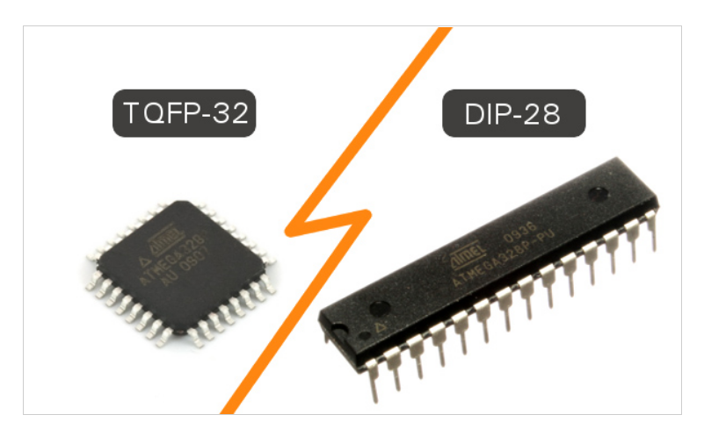

**Power:**

The MCU accepts supply voltages from 1.8 to 5.5 V. However, there are restrictions on the operating frequency; for example, if you want to use the maximum clock frequency (20 MHz), you need a supply voltage of at least 4.5 V.

**Digital I/O:**

This MCU has three ports: PORTC, PORTB, and PORTD. All pins of these ports can be used for general-purpose digital I/O or for the alternate functions indicated in the pinout below. For example, PORTC pin0 to pin5 can be ADC inputs instead of digital I/O.

There are also some pins that can be configured as PWM output. These pins are marked with “~” on the Arduino board.

ADC Inputs:

This MCU has six channels—PORTC0 to PORTC5—with 10-bit resolution A/D converter. These pins are connected to the analog header on the Arduino board.

One common mistake is to think of analog input as dedicated input for A/D function only, as the header in the board states ”Analog”. The reality is that you can use them as digital I/O or A/D.

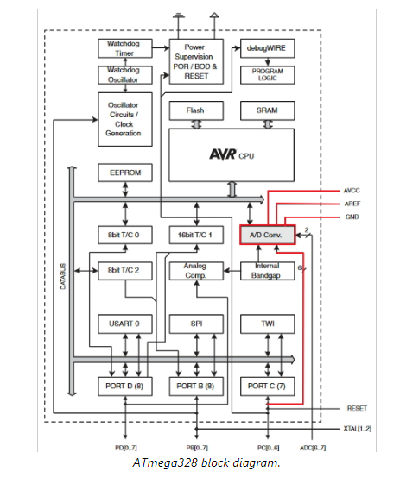

As shown in the diagram above (via the red traces), the pins related to the A/D unit are:

AVCC: The power pin for the A/D unit.

AREF: The input pin used optionally if you want to use an external voltage reference for ADC rather than the internal Vref. You can configure that using an internal register.

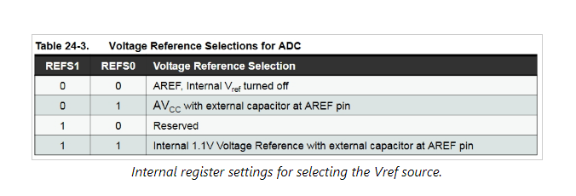

**UART Peripheral:**

A UART (Universal Asynchronous Receiver/Transmitter) is a serial interface. The ATmega328 has only one UART module.

The pins (RX, TX) of the UART are connected to a USB-to-UART converter circuit and also connected to pin0 and pin1 in the digital header. You must avoid using the UART if you’re already using it to send/receive data over USB.

**SPI Peripheral:**

The SPI (Serial Peripheral Interface) is another serial interface. The ATmega328 has only one SPI module.

Besides using it as a serial interface, it can also be used to program the MCU using a standalone programmer. You can reach the SPI's pins from the header next to the MCU in the Arduino NANO board or from the digital header as below:

11<->MOSI

12<->MISO

13<->SCK

**TWI:**

The I2C or Two Wire Interface is an interface consisting of only two wires, serial data, and a serial clock: SDA, SCL.

You can reach these pins from the last two pins in the digital header or pin4 and pin5 in the analog header.

**Other Functionality:**

Other functionality is included in the MCU, such as that offered by the timer/counter modules. You may not be aware of the functions that you don't use in your code. You can refer to the datasheet for more information.

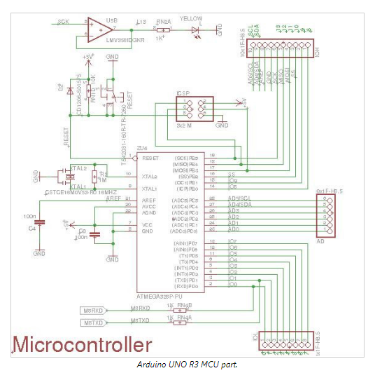

Returning to the electronic design, the microcontroller section has the following:

* ATmega328-PU: The MCU we just talked about.
* IOL and IOH (Digital) Headers: These headers are the digital header for pins 0 to 13 in addition to GND, AREF, SDA, and SCL. Note that RX and TX from the USB bridge are connected with pin0 and pin1.
* AD Header: The analog pins header.
* 16 MHz Ceramic Resonator (CSTCE16M0V53-R0): Connected with XTAL2 and XTAL1 from the MCU.
* Reset Pin: This is pulled up with a 10K resistor to help prevent spurious resets in noisy environments; the pin has an internal pull-up resistor, but according to the AVR Hardware Design Considerations application note (AVR042), “if the environment is noisy, it can be insufficient and reset may occur sporadically.” Reset occurs if the user presses the reset button or if a reset is issued from the USB bridge. You can also see the D2 diode. The role of this diode is described in the same app note: “If not using High Voltage Programming it is recommended to add an ESD protection diode from RESET to Vcc, since this is not internally provided due to High Voltage Programming”.
* C4 and C6 100nF Capacitors: These are added to filter supply noise. The impedance of a capacitor decreases with frequency:

The capacitors give high-frequency noise signals a low-impedance path to ground. 100nF is the most common value. Read more about capacitors in the AAC textbook.

* PIN13: This is connected to the SCK pin from the MCU and is also connected to an LED. The Arduino board uses a buffer (the LMV358) to drive the LED.
* ICSP (In-Circuit Serial Programming) Header: This is used to program the ATmega328 using an external programmer. It’s connected to the In-System Programming (ISP) interface (which uses the SPI pins). Usually, you don’t need to use this way of programming because bootloader handles the programming of the MCU from the UART interface which is connected using a bridge to the USB. This header is used when you need to flash the MCU, for example, with a bootloader for the first time in production.

**JUMPER WIRES:**

FIG 4.5 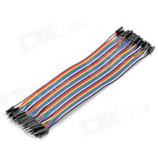

### Jumper wires are simply wires that have connector pins at each end, allowing them to be used to connect two points to each other without soldering.Jumper wires are typically used with breadboards and other prototyping tools in order to make it easy to change a circuit as needed

Though jumper wires come in a variety of colors, the colors don’t actually mean anything. This means that a red jumper wire is technically the same as a black one. But the colors can be used to your advantage in order to differentiate between types of connections, such as ground or power. The types are:

* Solid tips – are used to connect on/with a breadboard or female header connector. The arrangement of the elements and ease of insertion on a breadboard allows increasing the mounting density of both components and jump wires without fear of short-circuits. The jump wires vary in size and colour to distinguish the different working signals.
* [Crocodile clips](https://en.wikipedia.org/wiki/Crocodile_clip) – are used, among other applications, to temporarily bridge sensors, buttons and other elements of prototypes with components or equipment that have arbitrary connectors, wires, [screw terminals](https://en.wikipedia.org/wiki/Screw_terminal), etc.
* [Banana connectors](https://en.wikipedia.org/wiki/Banana_connector) – are commonly used on test equipment for DC and low-frequency AC signals.
* [Registered jack](https://en.wikipedia.org/wiki/Registered_jack) (RJnn) – are commonly used in telephone (RJ11) and computer networking (RJ45).

**9V BATTERIES:**

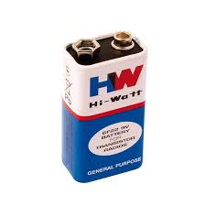

FIG 4.13

The nine-volt battery format is commonly available in primary carbon-zinc and alkaline chemistry, in primary lithium iron disulfide, and in rechargeable form in nickel-cadmium, nickel-metal hydride and lithium-ion. Mercury-oxide batteries of this format, once common, have not been manufactured in many years due to their mercury content

The size, regardless of chemistry, is commonly designated PP3—a designation originally reserved solely for carbon-zinc, or in some countries, *E* or *E-block*.

Most nine-volt alkaline batteries are constructed of six individual 1.5 V LR61 cells enclosed in a wrapper.

These cells are slightly smaller than LR8D425 [AAAA cells](https://en.wikipedia.org/wiki/AAAA_battery) and can be used in their place for some devices, even though they are 3.5 mm shorter. Carbon-zinc types are made with six flat cells in a stack, enclosed in a moisture-resistant wrapper to prevent drying.

Primary lithium types are made with three cells in series

**BREADBOARD:**

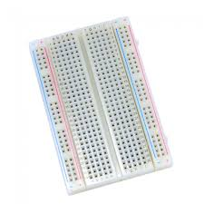

FIG 4.15

A breadboard is a construction base for [prototyping](https://en.wikipedia.org/wiki/Prototype) of [electronics](https://en.wikipedia.org/wiki/Electronic_circuit). Originally the word referred to a literal bread board, a polished piece of wood used for slicing bread.

 In the 1970s the solderless breadboard (a.k.a. plugboard, a terminal array board) became available and nowadays the term "breadboard" is commonly used to refer to these.

Because the solderless breadboard does not require [soldering](https://en.wikipedia.org/wiki/Soldering), it is reusable. This makes it easy to use for creating temporary prototypes and experimenting with circuit design. For this reason, solderless breadboards are also popular with students and in technological education. Older breadboard types did not have this property.

A [stripboard](https://en.wikipedia.org/wiki/Stripboard) ([Veroboard](https://en.wikipedia.org/wiki/Veroboard)) and similar prototyping [printed circuit boards](https://en.wikipedia.org/wiki/Printed_circuit_board), which are used to build semi-permanent soldered prototypes or one-offs, cannot easily be reused.

A variety of electronic systems may be prototyped by using breadboards, from small analog and digital circuits to complete [central processing units](https://en.wikipedia.org/wiki/Central_processing_unit)(CPUs).

**PCB**

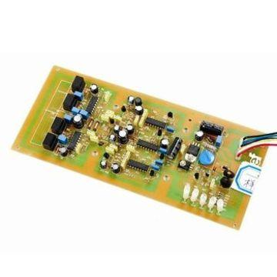

Printed circuit board is the most common name but may also be called "printed wiring boards" or "printed wiring cards". Before the advent of the PCB circuits were constructed through a laborious process of point-to-point wiring. This led to frequent failures at wire junctions and short circuits when wire insulation began to age and crack.

A significant advance was the development of [wire wrapping](http://en.wikipedia.org/wiki/Wire_wrap), where a small gauge wire is literally wrapped around a post at each connection point, creating a gas-tight connection which is highly durable and easily changeable.

As electronics moved from vacuum tubes and relays to silicon and integrated circuits, the size and cost of electronic components began to decrease. Electronics became more prevalent in consumer goods, and the pressure to reduce the size and manufacturing costs of electronic products drove manufacturers to look for better solutions. Thus was born the PCB.

PCB is an acronym for printed circuit board. It is a board that has lines and pads that connect various points together. In the picture above, there are traces that electrically connect the various connectors and components to each other. A PCB allows signals and power to be routed between physical devices. Solder is the metal that makes the electrical connections between the surface of the PCB and the electronic components. Being metal, solder also serves as a strong mechanical adhesive.

**SOFTWARE COMPONENTS:**

**Aurdino ide**



Arduino IDE: The Arduino integrated development environment (IDE) is a cross-platform application (for Windows, macOS, Linux) that is written in the programming language Java. It is used to write and upload programs to Arduino compatible boards, but also, with the help of 3rd party cores, other vendor development boards.

The source code for the IDE is released under the GNU General Public License, version 2. The Arduino IDE supports the languages C and C++ using special rules of code structuring. The Arduino IDE supplies a software library from the Wiring project, which provides many common input and output procedures. User-written code only requires two basic functions, for starting the sketch and the main program loop, that are compiled and linked with a program stub main() into an executable cyclic executive program with the GNU toolchain, also included with the IDE distribution. The Arduino IDE employs the program avrdude to convert the executable code into a text file in hexadecimal encoding that is loaded into the Arduino board by a loader program in the board's firmware.

**Working:**

* We are using Arduino Nano Development Board to control our project. Which have 8bit Atmega328PU controller with ISP programmer.
* To measure the surrounding obstacle, we had used ultrasonic sensor, which are capable to measure obstacle up to 450cm.
* We programmed in a way our arduino track the surrounding obstacle and once obstacle comes under predefine range arduio commands the TF-Mini player to play the specific audio file.
* This audio file we are stored in memory card in MP3 format.
* Mean while it also starts the vibrator
* Ultrasonic Sensor is a transducer which uses the physical characteristics and various other effects of ultrasound of a specific frequency which may transmit or receive the ultrasonic signal of a particular strength.
* These are available in electromagnetic or piezoelectric versions.
* The piezoelectric type is generally preferred due to its lower cost and simplicity to use comparatively than other types.
* The system mainly lies on the principle of Ultrasonic Range Finding sensor or simply an ultrasonic sensor. It works on 40 KHz ultrasonic sound wave which when triggered by its transmitter module, its receiver module receives back the echo of the triggered signal, having a sensing angle of 30°
* The concept of obstacle detection by SONAR sensor has been used here.
* As soon as the obstacle is detected by the sensor, its distance it sent to the customized PCB.
* We convert the distance into centimeters from milliseconds and the check whether the distance of obstacle is less than 3m, if yes then we send the output through a speaker and vibrator.
* The vibrator will vibrate as the obstacle is detected by the sensor and the user will be informed about the distance through the speaker with a preset voice message so that the user may move away from the obstacle .
* The Ultrasonic transmitter transmits an ultrasonic wave, this wave travels in air and when it gets objected by any material it gets reflected back toward the sensor this reflected wave is observed by the Ultrasonic receiver module.
* The sensor is small and offers excellent non-contact range detection between 2 cm to 400 cm (that’s about an inch to 13 feet) with an accuracy of 3mm. Since it operates on 5 volts, it can be hooked directly to an Arduino or any other 5V logic microcontrollers.
* In our project it is connected to an Arduino. Once the sensor detects an obstacle it sends the signal to arduino and in collaboration with other components the user is informed about the obstacle.
* The DF player mini is also connected to the arduino through the pcb. It has preset audio files saved in a SD(Secure Digital) card about the distance at which the obstacle is detected.
* Once the obstacle is detected the audio file will be played and the user will hear it through any device eg: earphone or speakers.
* The earphone will be connected to an audio jack which is on the pcb Likely the coin vibration motors are integrated with the arduino through pcb and they vibrate whenever the obstacle is detected and thus the user is informed.
* Through all this signals that is the sound through the earphone and vibration of the coin vibration motor the user will know about the obstacle in its path and can change the direction to avoid the obstacle

**CODE:**

#include <SoftwareSerial.h> //lab for MP3 Player  
  
#include <DFPlayer_Mini_Mp3.h> //MP3 Player lab  
  
SoftwareSerial MP3Serial =  SoftwareSerial(8,7); //Serial interfacing at pin No:8,7 MP3 Player  
  
//----------------------------------------------------------------------------------------------  
//Following Function call For Serial MP3 Response Monitor  
  
void showResponse(int waitTime){ //MP3 Player  
   
    long t=millis(); //MP3 Player  
     
    char c; //MP3 Player  
     
    while (t+waitTime>millis()){ //MP3 Player  
       
      if (MP3Serial.available()){ //MP3 Player  
         
        c=MP3Serial.read(); //MP3 Player  
  
        if (1) Serial.print(c); //MP3 Player  
         
      } //MP3 Player  
       
    } //MP3 Player  
                   
} //MP3 Player  
  
//-------------------------------------------------------------------------------------------------

#define trigPin1 3//ultrasonic1 Pin asign  
  
#define echoPin1 2 //ultrasonic1 Pin asign  
  
#define vibrator A0 //vibrator Pin asign  
  
  
void setup()  
  
{  
  
  Serial.begin(9600); // Setting Controller speed at 9600 Baud Rate  
   
  MP3Serial.begin (9600); //Setting MP3 speed at 9600 Baud Rate  
   
  showResponse(1000); //MP3 Player  
   
  mp3_set_serial (MP3Serial);  //MP3 Player  
   
  showResponse(1000); //MP3 Player  
   
  delay(1); //MP3 Player  
   
  mp3_set_volume (30); //MP3 Player  
   
  showResponse(1000); //MP3 Player  
   
  pinMode(trigPin1, OUTPUT); //ultrasonic  
  
  pinMode(echoPin1, INPUT); //ultrasonic  
  
  pinMode(vibrator,OUTPUT); //vibrator  
  
}  
  
  
void loop()  
  
{  
  
long duration1, distance1; //ultrasonic  
  
digitalWrite(trigPin1, LOW);  //ultrasonic  
  
delayMicroseconds(2); //ultrasonic  
  
digitalWrite(trigPin1, HIGH); //ultrasonic  
  
delayMicroseconds(10); //ultrasonic  
  
digitalWrite(trigPin1, LOW); //ultrasonic  
  
duration1 = pulseIn(echoPin1, HIGH); //ultrasonic  
  
distance1 = (duration1/2) / 29.1; //ultrasonic  
  
Serial.println(distance1);  
  
    if(distance1 < 20) //ultrasonic  
     
    {  
       
    analogWrite(vibrator, 150); //vibrator  
     
    mp3_play (0003); //MP3 Player  
     
    delay (3000); // delay  
     
    }  
     
    else if(distance1 < 50) //ultrasonic  
     
    {  
      analogWrite(vibrator, 200); //vibrator  
       
      mp3_play (0002); //MP3 Player  
       
      delay (3000); // delay  
       
    }  
     
    else if(distance1 < 80) //ultrasonic  
     
    {  
       
      analogWrite(vibrator, 255); //vibrator  
       
      mp3_play (0001); //MP3 Player  
       
      delay (3000); // delay  
       
    }  
     
    else  
     
    {  
       
    analogWrite(vibrator, 0);  //vibrator  
       
    mp3_stop (); //MP3 Player  
     
    }  
  
}

**FUTURE SCOPE:**

the mobility of people registered as blind could be improved. With the upcoming technology the type of object can be detected and the user can be informed about the same

**CONCLUSION:**

Hence, by using this glass the visually impaired people will not be dependent on any external guidance. obstacles at certain distance will be detected by the smart glass and a vibration or sound will be produced by the device through which the user will be informed about the obstacle